Doctor Blue Documentation



1.Introduction

1.1 Scope of this document

This document's objectives are to provide a project overview, specifics and background data. After reading the document, one should have a general understanding of how the application was created, the architecture used, the project's structure, and how the program works.

1.2 Project Idea

Our app represents a webpage from which one user can create , edit, delete ,see appointments and also see the doctors.

One appointment is defined by the following fields:

• patient_id(int)

• doctor_id(int)

• location(String)

• date(Date)

• time(Time)

• type(String)

A doctor is defined by the following fields:

id_doctor(int)

first_name(int)

last_name(String)

email(String)

password(String)

specialization(String)

hospital(String)

position(String)

A patient is defined by the following fields:

cnp_patient(String)

email(String)

password(String)

first_name(String)

last_name(String)

address(String)

city(String)

county(String)

country(String)

date_of_birth(Date)

Technologies and Applications Used

Backend implementation Python , Flusk

Frontend implementation JavaScript

Frontend library used ReactJS

Web page implementation HTML, CSS

Git repository management GitHub

Main flow

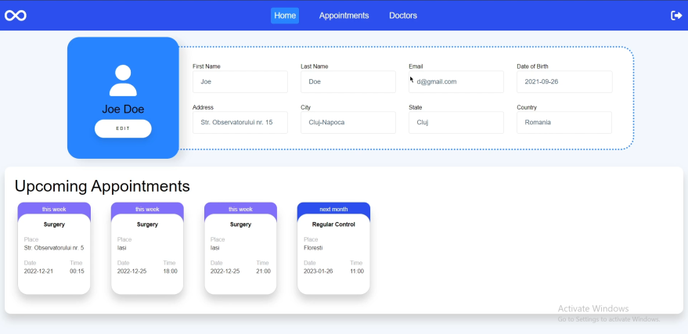

As a user if you want to make an appointment you need to press ‘Appointments’ followed by pressing ‘Add’.

The user inputs patient name , location , date and then chooses from a drop down the time and type of the appointment. To finalize the action the Create button must be pressed.

As a user if you want to edit an appointment you need to press the button which is on the same raw as Appointment that is affected.

The user can change patient name , location , date and then chooses from a drop down the time and type of the appointment. To finalize the action the Edit button must be pressed.

As a user if you want to delete an appointment you need to press the Delete button which is on the same raw as Appointment that is affected.